System Testing Documentation
Course: Software Testing
Worked by: Abdulaziz Bezan

System Test 2: Customer Management
Test Type: System Testing
This test validates the complete Customer Management module, including UI behavior, business logic, and database interactions for viewing, adding, searching, updating, and deleting customer records.
Testing Level: End-to-End System Level
Tests the full system flow from user interaction in the Customer UI through database operations and back to the UI. Through admin as it is the face of all database operations.
Objective
To verify that the Customer Management feature correctly displays existing customers, allows searching by name, and that the Add, Update, and Delete functions work as intended.
Description
This test examines the Customer Information interface, where a table displays pre-saved customer records (ID, Name, Phone No). The test validates the functionality of all available buttons: Search, Add, Delete, and Update.
Preconditions
- User is logged into the POS system as admin.
- The customers table exists in the database and contains prepopulated records.
- The Customer UI is accessible from the main navigation menu.

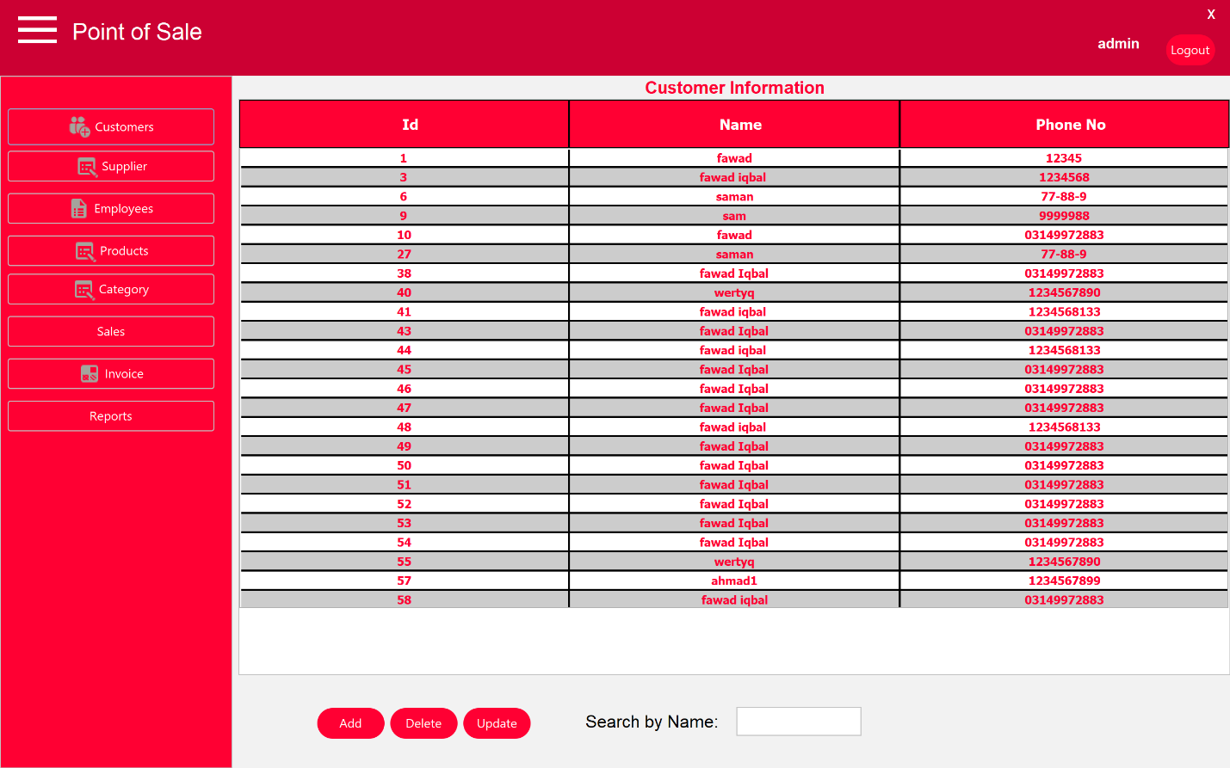
Test Data
Existing customers include:
- fawad (12345)
- fawad iqbal (1234568)
- saman (77-88-9)
- sam (999998)
Test Steps
- Navigate to the Customer UI.
- Observe the displayed list of customers.
- Enter a customer name in the Search by Name field.
- Click the Search button.
- Click the Add button.
- Click the Delete button on an existing customer.
- Select a customer and click Update.
Expected Result
- Customer list displays correctly without errors.
- Search filters the list based on entered text.
- Add opens a form for new customer details.
- Delete removes the selected customer after confirmation.
- Update allows editing of selected customer details.
Actual Result
- ✅ Customer list displayed correctly with pre-saved data.
- ❌ Search caused the list to become empty immediately when typing, even with valid names.
- ❌ Add button displayed an error immediately: “invalid character size.”
- ✅ Delete button worked as intended and removed selected customers.
- ❌ Update functionality could not be tested due to the Add feature failing.
Test Result
PARTIAL PASS — Some functions work, but critical features are broken.
System Components Involved
Customer UI, POS Controller, Data Access Layer (DALManager), MySQL Database (customers table)
Observations
Customer display and deletion work correctly. However, the search functionality is completely broken, clearing the list instead of filtering results. The Add function fails immediately, preventing new customer creation and blocking the Update feature.

System Test 3: Supplier Management
Test Type: System Testing
This test validates the complete Supplier Management module, ensuring supplier data can be saved, searched, updated, and cleared through the UI and database layers.
Testing Level: End-to-End System Level
Validates full integration from Supplier UI input to database storage and retrieval.

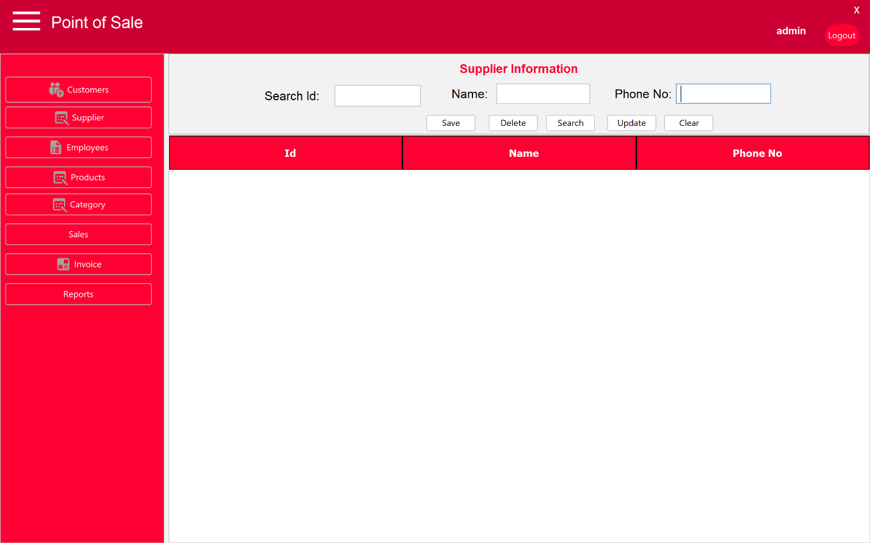
Objective
To verify that the Supplier Management feature correctly handles supplier information, with functional Save, Search, Update, Delete, and Clear operations.
Description
This test checks the Supplier Information interface, which includes fields for Search ID, Name, and Phone No, along with Save, Delete, Search, Update, and Clear buttons. An empty table is intended to display supplier records.
Preconditions
- User is logged into the POS system as admin.
- Supplier UI is accessible from the main navigation.
- The suppliers/vendors table exists in the database.
Test Data
Test inputs attempted:
- Name: Various text entries
- Phone No: Various numeric entries
Test Steps
- Navigate to the Supplier UI.
- Enter supplier details (Name and Phone No).
- Click the Save button.
- Enter text in the Search field.
- Click the Search button.
- Click the Clear button.
- Select a supplier (if available) and click Update.
- Click the Delete button.
Expected Result
- Save stores supplier data and displays it in the table.
- Search filters suppliers based on entered criteria.
- Clear resets input fields.
- Update modifies existing supplier records.
- Delete removes selected suppliers.
Actual Result
- ❌ Save displayed “successfully saved to the table,” but no data appeared in the list.
- ❌ Search could not be verified because no suppliers were ever displayed.
- ✅ Clear button worked correctly, resetting input fields.
- ❌ Update showed a failure message when fields were empty but no success message when valid data was used.
- ❌ Delete could not be tested since no supplier data appeared.
Test Result
FAIL — Core functionality is not working.
Observations
The Supplier module is largely non-functional. Despite success messages, data is not displayed, making Search, Update, and Delete impossible to verify. The Clear function is the only feature that works correctly.

System Test 4: Employee Management
Test Type: System Testing
This test validates the Employee Management module, ensuring employee records can be managed through the UI with correct database integration.

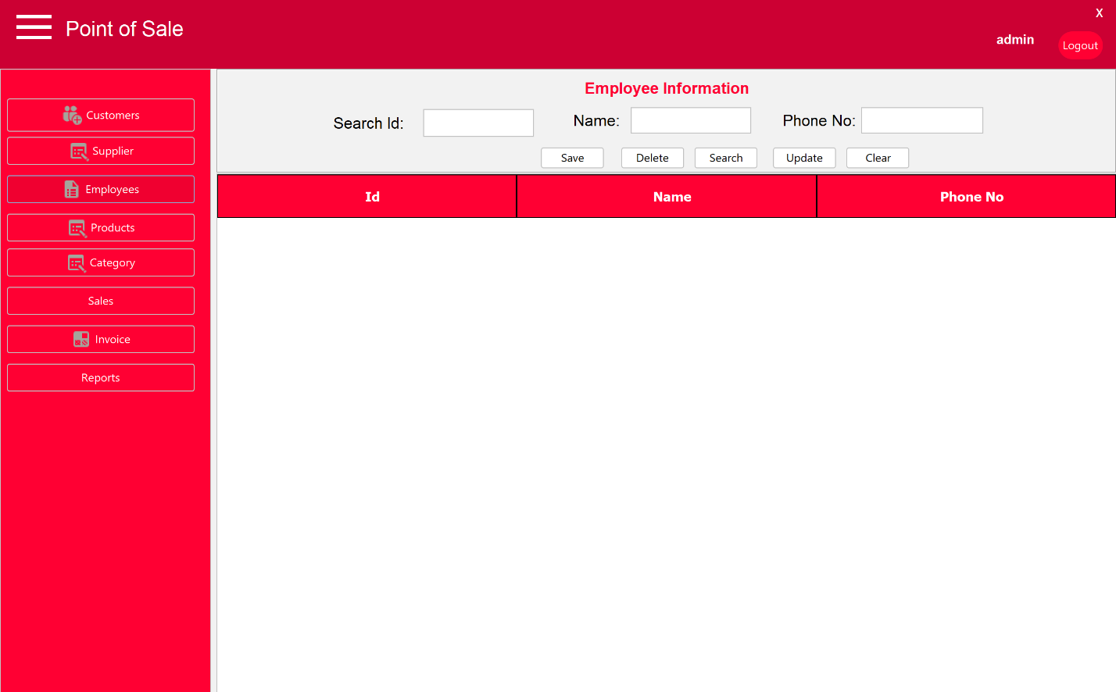
Objective
To verify that employee data can be saved, searched, updated, and deleted with correct system messages.
Actual Result (Key Issues)
- ❌ Save button displayed an incorrect success message: “saved to supplier table” instead of “employee table.”
- ❌ Search, Update, and Delete showed the same issues as the Supplier module (no data displayed).
- ✅ Clear button worked correctly.
Test Result
FAIL — Incorrect messages and broken functionality.
Observations
Employee Management suffers from the same core issues as Supplier Management, with the additional error of referencing the wrong database table in success messages.

System Test 5: Product Management
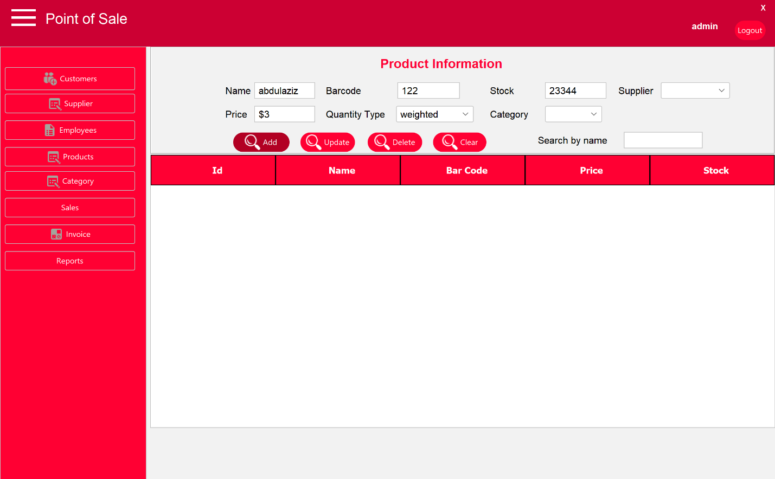
Test Result: FAIL — Entire module non-functional
All buttons were unresponsive, dropdowns were empty, and no product data was displayed. This completely blocks sales operations.
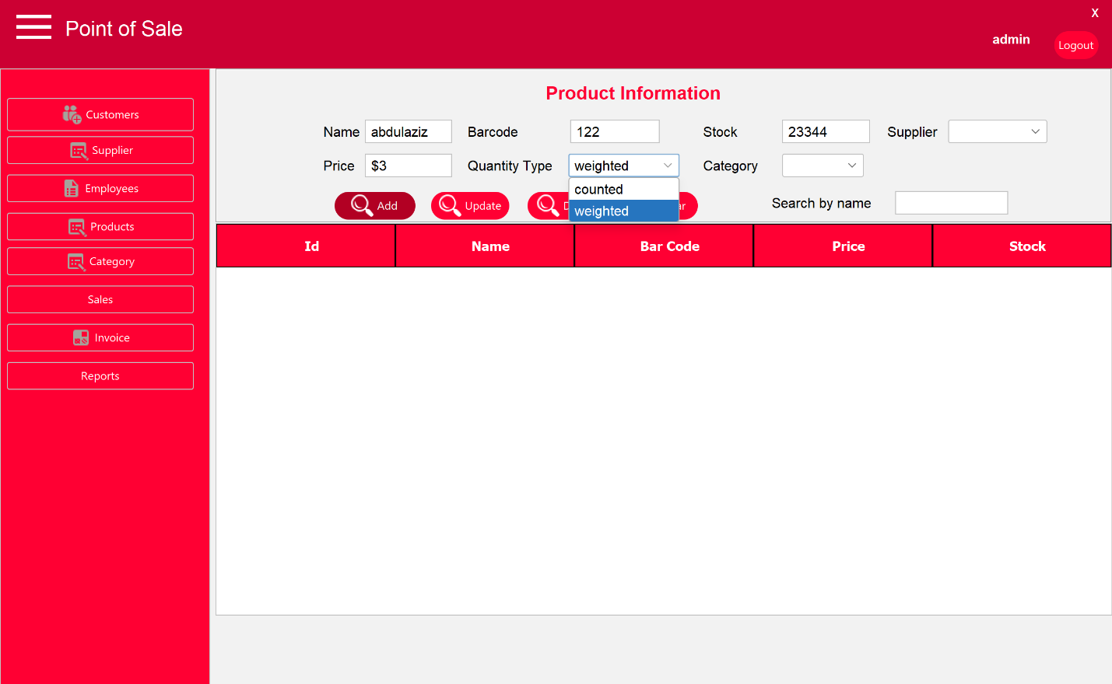

System Test 6: Sales Transaction Processing

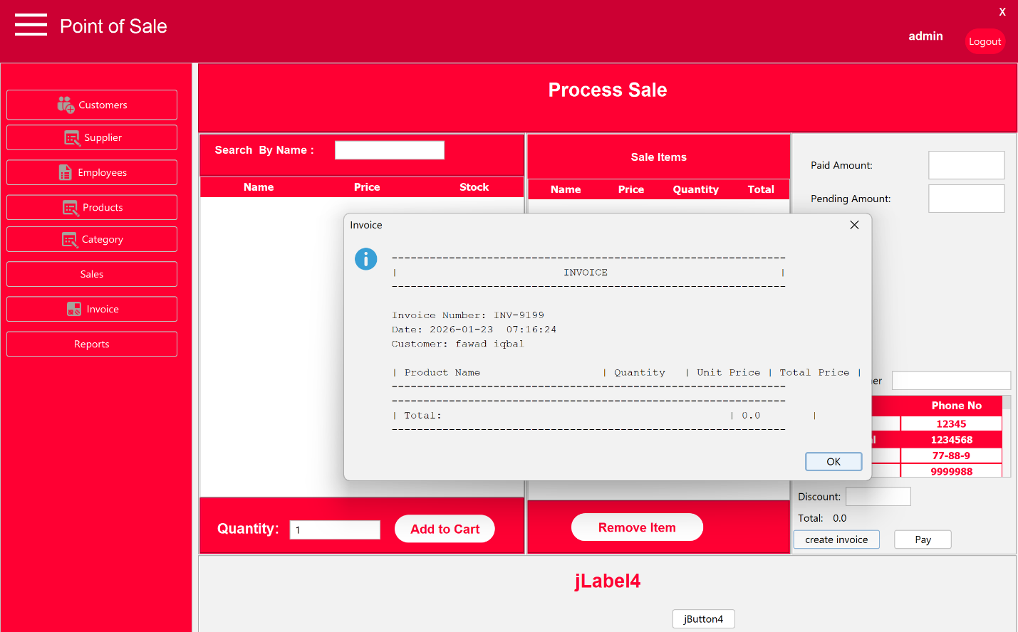
Test Result: FAIL
- Product list empty due to broken Product module.
- Invoice generation partially works (header only, total = 0).
- Payment and cart operations fail.
- Search inputs break UI lists.

System Test 7: Invoice and Reports Modules

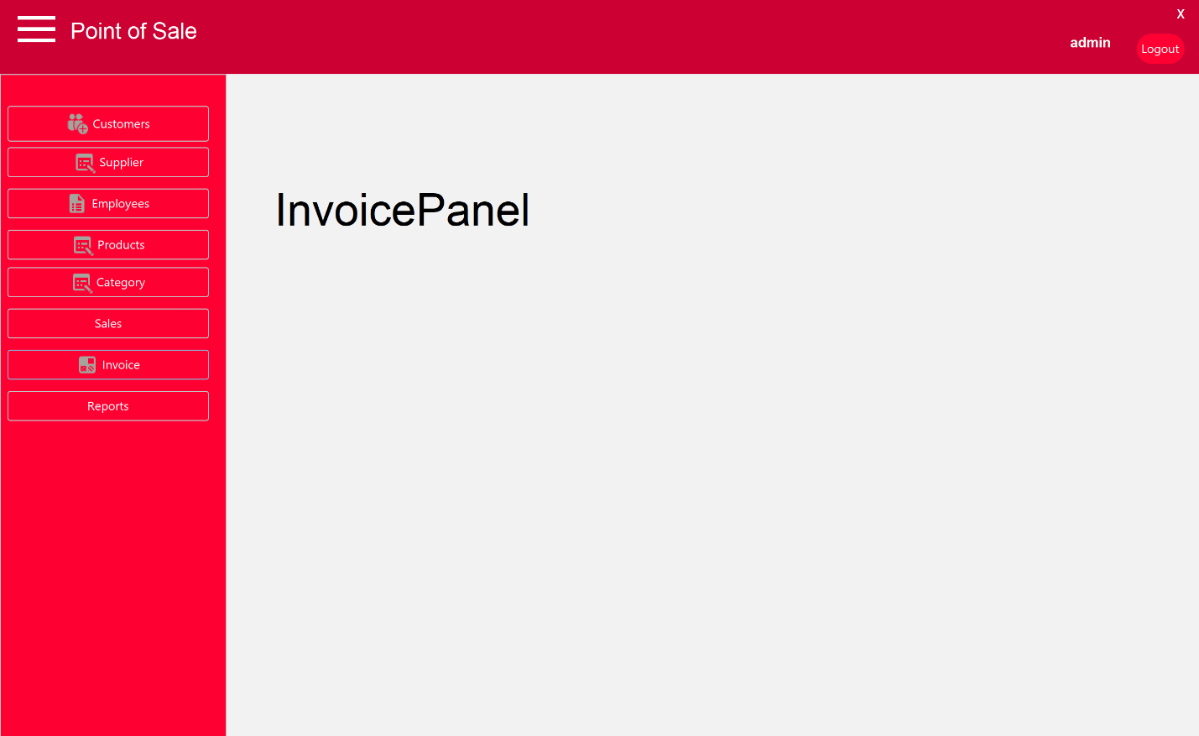

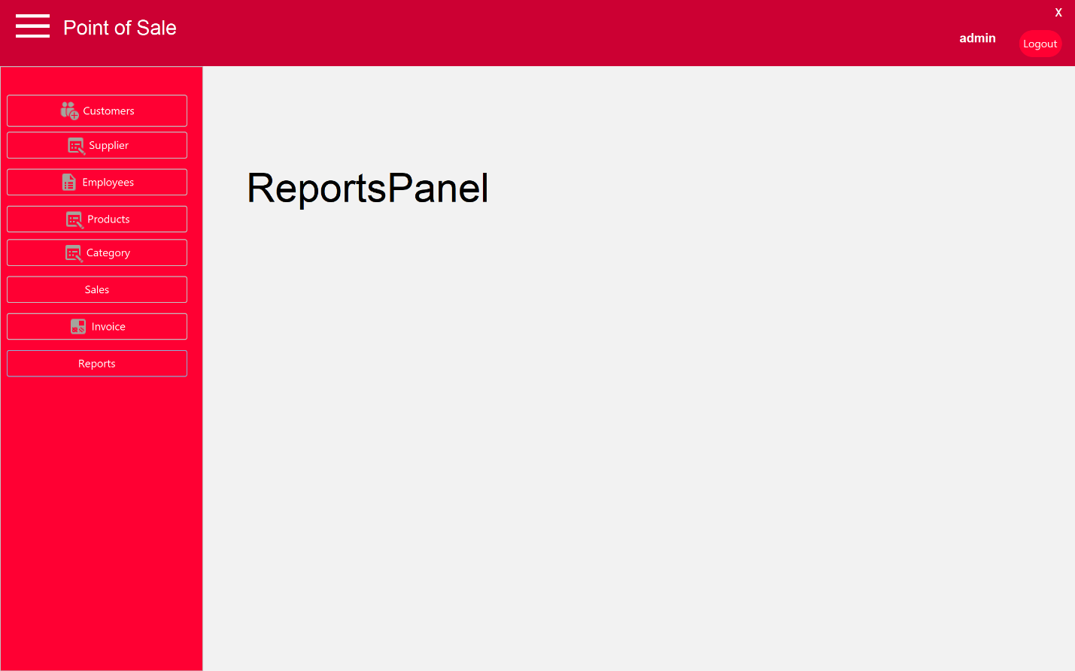
Test Result: FAIL
Invoice and Reports pages display only the navigation sidebar with no functional content, indicating missing or unimplemented modules.

Summary of System Test Results
Module | Test Result | Key Issues
Login | PASS | Works correctly
Customer Management | PARTIAL PASS | Search broken, Add fails
Supplier Management | FAIL | Data not displayed
Employee Management | FAIL | Wrong messages, no data
Product Management | FAIL | Entire module broken
Sales Processing | FAIL | No products, buttons fail
Invoice Module | FAIL | Empty/unimplemented
Reports Module | FAIL | Empty/unimplemented

Overall System Assessment
The POS system has a functioning login module and limited customer functionality, but most core business modules are broken or incomplete. The most critical failure lies in the Product Management module, which causes cascading failures in Sales and Invoicing. Immediate fixes are required in database integration, UI event handling, and data rendering logic before the system can be considered operational.

Proposed Solutions
- Fix the search functionality in all modules so it filters data instead of clearing the table. Search should only run when the button is clicked and should handle empty input correctly.
- Review input validation rules, especially for the Add/Save functions. Field size limits in the UI should match the database column sizes to avoid validation errors like “invalid character size.”
- After saving data (Customer, Supplier, Employee), the system should reload and display the updated table. Insert operations should always be followed by a fresh fetch from the database.
- Correct incorrect system messages, such as the Employee module showing “saved to supplier table.” Messages should clearly match the correct module and database table.
- Fix button responsiveness by checking event handlers and controller connections. Buttons should trigger actions and not remain inactive after errors.
- Ensure dropdowns in the Product module (Supplier and Category) are populated from the database when the UI loads and that related tables contain data.
- Prioritize fixing the Product Management module, since its failure prevents Sales, Invoicing, and Reports from working properly.
- Once products are available, re-test the Sales workflow, including Add to Cart, invoice creation, and payment processing, and block invoice creation when no products are selected.
- Connect or implement the Invoice and Reports modules so they display data instead of empty screens, even if only basic tables are shown.
- Add basic error logging or messages so failures are visible during testing and easier to debug.

Test complete

